*R - ASSIGNMENT CODES*

1. **Here is the graphical representation**



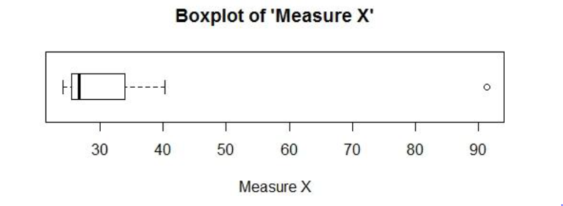

*μ = 33.27*

σ = 16.95

σ*2 =*  **287.152**

1. **Here are answers**

**i. What is inter-quartile range of this dataset? (please approximate the numbers)**

**Sol:** By looking at box plot, we can say that first quartile is 5 and third quartile is 12. Therefore, inter – quartile range is =12-5=7.

The Inter-quartile range indicates that 50% of the values of variable X lie within the range of 7 units i.e. in the interval 5 to 12.

**ii. What can we say about the skewness of this dataset?**

**Sol:** By looking at the box-plot we can say that the distribution of X is right-skewed or positively skewed.

**iii. If it was found that the data point with the value 25 is actually 2.5, how would the new box-plot be affected?**

**Sol:** The outlier in the box-plot will vanish. From visual observation we can say that it will reduce the skewness of the data.

1. **i. Where would the mode of this dataset lie?**

**Sol:** The mode lies between values 4 and 8 (both included). We will need to have the actual data in order to calculate the exact value of mode.

**ii. Comment on the skewness of the dataset.**

**Sol:** The distribution of variable Y is right-skewed or positively skewed as the histogram has a long tail on the right side. It indicates that there are many very high values with low frequency.

**iii. Suppose that the above histogram and the box-plot in question 2 are plotted for the same dataset. Explain how these graphs complement each other in providing information about any dataset.**

**Sol:** Box plot tell us min, max, median, first and third quartile. However, it doesn’t give us the mode information.

On the other hand, histogram gives information about mode. But it would not be easy to extract the values of above mentioned statistics from a histogram.

Also, both the plots clearly indicate the skewness of the dataset for which they are plotted.

4. Call not misdirected Q = 200 - 1 /200 = 199/200

= 1 – Q(a given call not misdirected)5

= 1 – (199/200)^5

= 0.0248

Hence probability that at least one in five attempted long-distance telephone calls reaches the wrong number is 0.0248.

5. i. What is the most likely monetary outcome of the business venture?

Sol: $2000

ii. Is the venture likely to be successful? Explain

Sol: Yes, the venture will succeed. There is a 60% probability (0.2+0.3+0.1) that it would likely to succeed.

iii. What is the long-term average earning of business ventures of this kind? Explain

Sol: The average returns would be $800.

iv. What is the good measure of the risk involved in a venture of this kind? Compute this measure.

Sol: The standard deviation of the returns is 1469.69. This large value of standard deviation considered along with the average returns of $800 indicates that this venture is highly risky.